KSU Go

Software Development Plan

Version 1.1.2

Team 5

Albert Lim

Chase Godwin

Nick Wilson

Anthony Schell

Dayton Chamberlin

Patrick Hilerio

*[Note: The following template is provided for use with the Rational Unified Process. Text enclosed in square brackets and displayed in blue italics (style=InfoBlue) is included to provide guidance to the author and should be deleted before publishing the document. A paragraph entered following this style will automatically be set to normal (style=Body Text).]*

*[To customize automatic fields (which display a gray background when selected), select File>Properties and replace the Title, Subject and Company fields with the appropriate information for this document. After closing the dialog, automatic fields may be updated throughout the document by selecting Edit>Select All (or Ctrl-A) and pressing F9, or simply click on the field and press F9. This must be done separately for Headers and Footers. Alt-F9 will toggle between displaying the field names and the field contents. See Word help for more information on working with fields.]*

Revision History

|  |  |  |  |
| --- | --- | --- | --- |
| **Date** | **Version** | **Description** | **Author** |
| 21/Jan/18 | 1.0 | Added basic information and began the document. | Nick Wilson |
| 23/Jan/18 | 1.1 | Updated document for first weekly report | Anthony Schell |
| 17/Mar/18 | 1.1.1 | Appended updated project schedule to accurately reflect specific objectives for our capstone project | Anthony Schell |
| 20/Mar/18 | 1.1.2 | Appended updated project roles relative to team assignment for clear differentiation.  Added the project schedule based on design and schedule for project specific deliverable | Anthony Schell, Albert Lim |

Table of Contents

**Introduction** **4**

Purpose 4

Scope 4

Overview 5

Definitions, Acronyms and Abbreviations 5

**Project Overview** **5**

Project purpose, scope and objectives 5

Assumptions and constraints 5

Project deliverables 6

**Project Organization** **6**

Organizational Structure 6

External Interfaces 7

Social and Ethical Issues 7

**Management Process** **7**

Project Plan 7

Phase Plan 7

Project Schedule 7

Project Monitoring and control 11

Schedule control plan 11

Reporting Plan 11

**Supporting process plans** **11**

Documentation plan 11

Software Development Plan

# Introduction

In the current emerging technology world, mobile devices such as smartphones and tablets are growing rapidly. Based on Meeker, U.S. users are spending 51% of their total time online accessing online content via mobile devices (Sauro and Zarolina, 2017). There are two ways to approach the use of smartphone apps: responsive web app and native/ hybrid app. With responsive web app, the app features can only be accessed through the browsers in the phone. However, the native/ hybrid app can utilize the built-in software such as the navigation Map app, as well as built-in hardware such as camera (Wright, 2017). The mobile native/ hybrid apps are also more trending for social networking and even shopping. This project will focus on mobile native/ hybrid app development as it has a better user experience. According to Sauro and Zarolia’s findings (2017), 22% of users choose a mobile app because it offers features its mobile website does not. They also conclude that there are four main reasons of using mobile apps. First, users like the way their favorite app integrates with other apps or features on their phone. Second, users enjoy apps that allow them to connect with their friends or colleagues. Third, users frequently use communication features in their app. Fourth, users enjoy apps with features that integrate with real world products. All of these reasons are why this project will also focus on improving the user experience of students during their time at Kennesaw State University.

## Purpose

The purpose of this Software Development Plan (SDP) is to serve as a guiding document over the creation of the KSU Go mobile app. Project members will use this document as a point of reference in terms of due dates and guiding principles. Dates and deliverables on this document may be subject to change.

## Scope

The scope of this SDP is solely focused on the KSU Go app and its affiliated dependencies/assets. This include potential use of BOB (Big Owl Bus) location data and Kennesaw State University student data. These are subject to change as approval is granted or denied.

## Overview

This SDP contains definitions of acronyms this project uses, a description of the team structure, any external interfaces utilized, ethical issues and considerations, the overall management process, supporting processes, and references used during the development of the project.

## Definitions, Acronyms and Abbreviations

KSU- Kennesaw State University

SDP- Software Development Plan

SRS- Software Requirements Specification

SDD- Software Design Description

D2L- Desire to Learn

# Project Overview

## Project purpose, scope and objectives

The purpose of this project is to deliver a mobile app that is focused on improving the student experience at KSU. It will be available to both Android and IOS users and feature information about the campus, such as a campus directory, a link to emergency services, D2L, Owl Life, Handshake (career planning), and social feeds.

The driving objective behind this project is to improve the student experience through a user friendly mobile app. Part of the problem with student involvement is poor communication of relevant information, and this app will be focused at presenting this in a visually pleasing, easy to access manner.

Our deliverables are going to be documentation of the project and three different phases of the software. Phase one will be an early prototype of the application, phase two will be adding cores systems and removal of superfluous features, and the third phase will be finalization and polish of KSU Go.

## Assumptions and constraints

This KSU Go application is built on the premise that 6 students are to be working throughout the semester to deliver a finished product. We currently have both Android and iOS phones to use for demonstration and testing purposes as well as Macintosh and Windows computers for development. Further development on the application post due date will be at the discretion of the KSU administration.

## Project deliverables

* + 1. Phase 1: Prototype
       1. Due Date: 02/06/2018
          1. Description: In this phase, we will develop a working prototype of KSU Go. It will have some basic features along with a rough UI design. One of the main focus’ will be compiling a list of the features the application will have, and have a time table of to when the project will be completed. The project scope and gantt chart will be completed.
    2. Phase 2: Implementation
       1. Due Date: 03/13/2018
          1. Description: In this phase, our SRS will be completed. Along with implementing the core systems of the application. Core systems will include: BOB tracking, D2L integration, KSU News feature, etc. Any changes to the UI will be made here. The SRS and the SDD will be developed in this phase.
    3. Phase 3: Final stages
       1. Due Date: 04/24/2018
          1. Description: The final phase will have the completed application. All features will be up and running. Any documentation needed will be available as well.

# Project Organization

## Organizational Structure

Team Leader: Albert Lim

Team Members: Nick Wilson, Chase Godwin, Anthony Schell, Dayton Chamberlin, and Patrick Hilerio

Lead code developers: Patrick Hilerio, Dayton Chamberlin, Chase Godwin, and Albert Lim

Features implementations:

* Albert Lim: Directory, Events, BOB, Handshake, and Emergency
* Patrick Hilerio: Full fledge features of D2L: News, Assignments, Courses, and Grades.
* Dayton Chamberlin: Login, Interactive Maps, and Homepage for guest, faculty and student
* Chase Godwin: News Feed from Facebook and Twitter
* Anthony Schell: Owl Life

Application structure: Dayton Chamberlin and Anthony Schell

Code review: Chase Godwin and Anthony Schell

Database & backend: Nick Wilson

Project documentations: All group members

Powerpoint & poster management: Albert Lim, Chase Godwin, and Anthony Schell

## External Interfaces

Professor He will be our faculty liaison with regards to completing this project according to our specifications. Any questions or concerns that our group has will be brought to the attention of Professor He.

## Social and Ethical Issues

The primary social and ethical issues related to the project are based in private information possibly being used to contribute to the ease of access that the application provides, such as class schedules, or living accomodations. Issues in determining the scope of the project are due to the availability of information and access from BOB or KSU in being able to use real-time data for the project. Security issues related to the aforementioned may inhibit the use of more private information such as grades or financial venues related to KSU.

# Management Process

## Project Plan

### *Phase Plan*

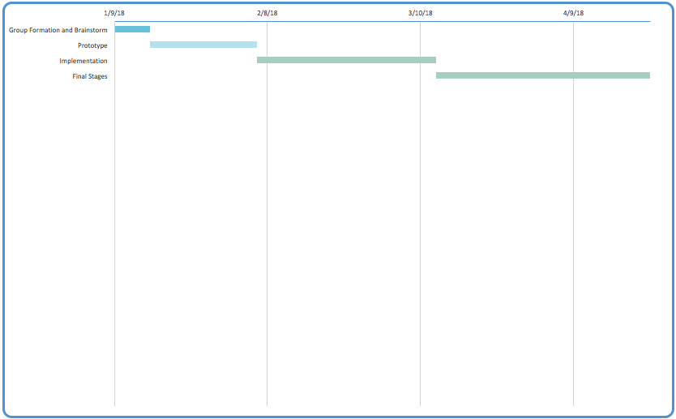

### Project Schedule

* Phase 1 (Group formation and Brainstorm) - 7 days
  + Assignment of roles for capstone project, plan structure of application and decide hardware/software constraints and limitations
  + Design layout of application and content of features, set goals relative to each for expected output and projected time to complete each (Phase 2 for initial basic functionalities, Phase 3 & 4 for bonus functionalities and time for honors additions)
* Phase 2 (Prototype) - 21 days
  + Include functionalities in working form (possibly unstable, most stable build for update presentation) as well as development of structure for next phase
  + Expectation of completed features: D2L w/ spoof data, Handshake, Emergency Services
  + Features to complete at end of phase 2/before update presentation: OwlLife, Events, Directory
* Phase 3 (Implementation) - 35 days
  + Clean coding portion of capstone project and continue documentation for bonus or unfinished features, ensure working processes throughout stable features
  + Primary objective of phase 3: Implementation of database/server with pre existing features, as well as addition of bonus features that utilize backend server
* Phase 4 (Final Stages) - 42 days
  + Preparation of coding portion for final update presentation as well as stable build for C-Day, removal of major issues and hardcoded facets to replace realistic mock application short of KSU-affiliated API
  + Code review and intensive testing to ensure integrity of app execution, fleshing out of features to provide useful aspects to students, faculty, guests
  + Features to complete at end of phase 4/before final update presentation: BOB, RSS News Feed, Interactive Map, Honors Disability Features

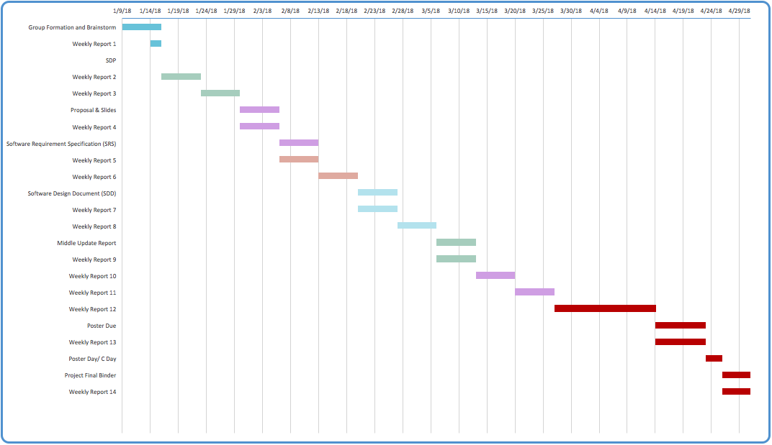

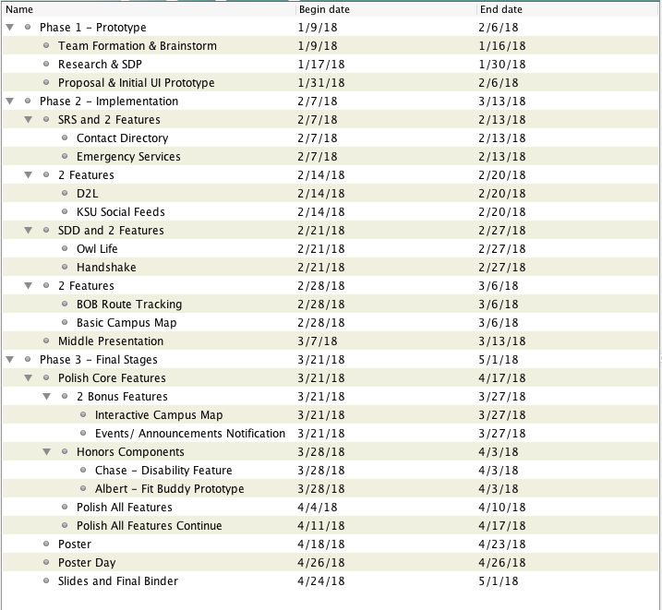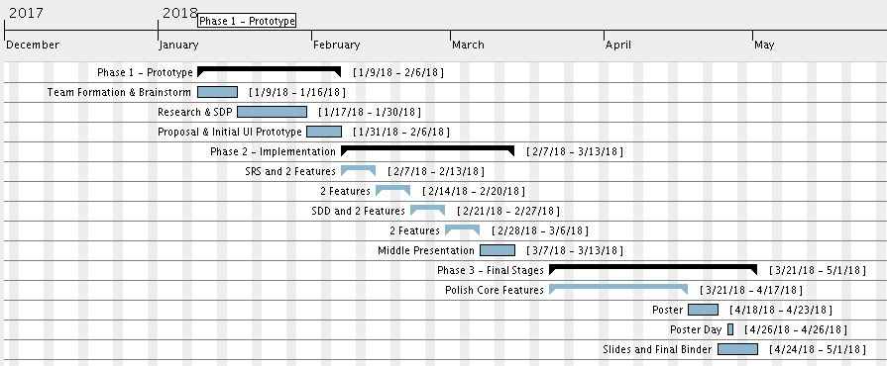

## Project Monitoring and control

### *Schedule control plan*

Progress will be monitored via weekly reports to the instructor and evaluated against the project schedule above. Should progress not be satisfactory, either due to self evaluation or from instructor feedback, a group meeting will be called at the team members’ earliest convenience to address the problem and create a plan of action. This plan may result in a reevaluation of project milestones and the removal of non essential features.

### *Reporting Plan*

Weekly reports are to be submitted via D2L to the instructor. While all team members may contribute, it is the responsibility of the project manager to submit these files in a timely fashion.

# Supporting process plans

## Documentation plan

The planned documents for this project:

* Project Proposal
  + Overview of the project, the project plan and requirements, and current status.
* SRS
  + Software Requirements Specification.
* SDD
  + Software Design Description.
* Update Report Specification
  + Work Progress Presentation: project design, implementation, and current status.
* Final Binder
  + Contains updated revisions of the above, an Updates Section that documents updates to the above, and an Implementation Section that includes code and documentation of future functions of the system.

1. References

* Sauro, J., & Zarolia, P. (2017). SUPR-Qm: A Questionnaire to Measure the Mobile App User Experience. Journal Of Usability Studies, 13(1), 17-37.
* Wright, N. (2017, November 20). Native App vs Web App: What's the Difference? Retrieved January 18, 2018, from https://www.upwork.com/hiring/mobile/native-app-vs-web-app-for-mobile/